Simple word

🔵 What is a Simple Word?
# Source: Chatgpt (GPT-4-turbo) at [7/24/2025]
A simple word is a word that cannot be broken down into smaller meaningful parts (morphemes).
It is made up of only one free morpheme — it does not include prefixes or suffixes.

📘 Definition:
# Source: Chatgpt (GPT-4-turbo) at [7/24/2025]
A simple word is a word that contains just one morpheme, meaning it has no affixes (no prefixes, suffixes, or inflections).

🧠 Examples of Simple Words:
# Source: Chatgpt (GPT-4-turbo) at [7/24/2025]
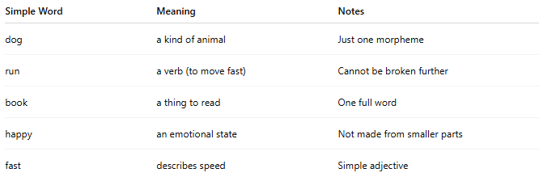
Simple Word | Meaning | Notes
dog | a kind of animal | Just one morpheme
run | a verb (to move fast) | Cannot be broken further
book | a thing to read | One full word
happy | an emotional state | Not made from smaller parts
fast | describes speed | Simple adjective

🆚 Simple Word vs Complex Word:
# Source: Chatgpt (GPT-4-turbo) at [7/24/2025]
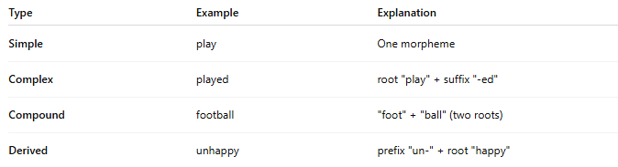
Type | Example | Explanation
Simple | play | One morpheme
Complex | played | root "play" + suffix "-ed"
Compound | football | "foot" + "ball" (two roots)
Derived | unhappy | prefix "un-" + root "happy"

✅ Summary:
# Source: Chatgpt (GPT-4-turbo) at [7/24/2025]
A simple word is a single, indivisible word with no prefixes or suffixes — it’s the basic form of a word.

